Title
First Author¹, Second Author², Third Author³, Fourth Author⁴….
¹Institutional Affiliation
²Institutional Affiliation
³Institutional Affiliation,
⁴Institutional Affiliation

Corresponding author: Author Name
Email:

Sub-theme:

Title
Abstract
The abstract should provide a concise and accurate summary of the full paper. It must be in single paragraph format without headings or subheadings. It should include a short statement of the problem or research context, the main objective of the study, a brief description of the methodology, key findings, and implications of the study. The word count should be between 200 and 250 words.
Keywords: 3-5 keywords
Introduction
The Introduction section should present a clear and coherent discussion of the study’s background, statement of the problem, theoretical or conceptual framework, research objectives, and significance of the study. These components must be integrated into a single, continuous narrative without the use of separate subheadings. The discussion should flow logically, using appropriate transitions to ensure clarity and coherence across ideas.
Methods
This section presents a clear and systematic description of the research methodology, including the research design, participants or data sources, sampling procedure, instruments or data collection tools, and data analysis methods. All elements should be discussed in a coherent and continuous narrative, ensuring logical flow and clear explanation of how the study was conducted, without the use of separate subheadings.
Results and Discussion
This section presents the findings, interpretation, and discussion of the study in relation to existing literature. The presentation should be integrated into a clear and coherent narrative, ensuring that results are not only described but also critically interpreted and linked to relevant studies and theoretical perspectives.
Tables and figures must be properly embedded within the manuscript and placed immediately after the paragraph where they are first cited. They should be positioned as close as possible to the corresponding discussion or interpretation to enhance clarity and readability. All tables and figures must be numbered sequentially throughout the manuscript (e.g., Table 1, Table 2; Figure 1, Figure 2).
An example of the required format is shown below:
As shown in Table 1, the sample table format illustrates the proper placement and formatting of the table title. The sample demonstrates how the title should be positioned above the table and formatted in accordance with the prescribed style guidelines.
Table 1. Sample table format
As shown in Figure 1, a sample figure format is provided, illustrating the proper placement and formatting of the figure title. The sample demonstrates that the title should be positioned below the figure, centered, and italicized in accordance with the prescribed style guidelines.
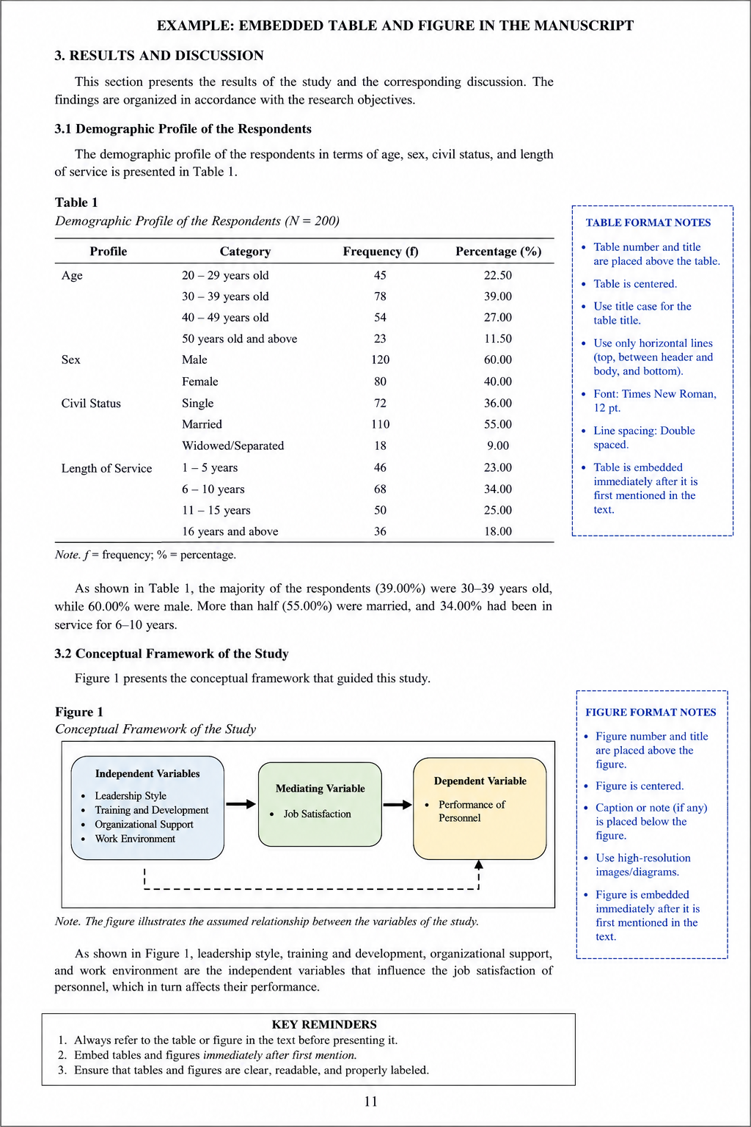
Figure 1. Sample figure

Conclusion
This section presents a concise synthesis of the study, including the summary of key findings, policy implications, limitations of the study, and recommendations for future research. The discussion should be written in a clear and coherent narrative, highlighting the most important results and their practical and theoretical implications, while also acknowledging the study’s limitations and providing well-founded directions for future research.
References (The following references are sample entries formatted according to the APA 7th edition. Replace them with your own references.)
Braun, V., & Clarke, V. (2006). Using thematic analysis in psychology. Qualitative Research
in Psychology, 3(2), 77–101. https://doi.org/10.1191/1478088706qp063oa
Creswell, J. W., & Creswell, J. D. (2018). Research design: Qualitative, quantitative, and
mixed methods approaches (5th ed.). SAGE Publications.

